**Macklin O’Rourke**

**Ted Kreutzer**

**Applied Business Technology**

**5/5/2019**

**NHL Rookie Points Predictor**

**PROBLEM:** How do you determine how productive an 18-year-old rookie will produce for your team? Many NHL general managers have to think about this when deciding which players to take in the NHL Entry Draft, where teams get their picks at the best 18-year old’s in the world. How do you choose between a player who barely scored in a professional European league, Vs a player who scored at will in a junior league? Different leagues vary tremendously in skill level, so how do you determine which player to select to represent your franchises future?

**IDEAL**: NHL GM’s can accurately estimate how many points a player will have in their first year in the NHL to assist on decision making such as drafting and free agent signings.

**REALITY**: There are many different hockey leagues in the world and each one has a different skill level. When teams are deciding on which players to draft or sign, they must consider that just because a player does well in one league, it does not mean that their production will translate to the NHL.

**CONSEQUENCES**:

-Teams may draft or sign players that do not produce well for them which wastes assets, and keeps the team in an uncompetitive state.

-Many players who are drafted into the NHL never pan out, and GM’s are left looking like fools for picking player X ahead of player Y who produced more points in the NHL.

**PROPOSAL**: The following steps should be taken in order to calculate the production of players in their first NHL season.

* Find their points per game in the previous league
* Find a multiplier value for their previous league based on previous NHL players to come from that league.
* Take into consideration their ice-time, and other potentially influential factors to estimate their production at the NHL level.

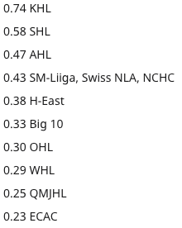

|  |  |
| --- | --- |
| LEAGUE | MULTPLIER |
| KHL | 0.83 |
| SHL | 0.78 |
| LIIGA | 0.54 |
| AHL | 0.44 |
| NCAA | 0.41 |
| OHL | 0.3 |
| WHL | 0.3 |
| QMJHL | 0.28 |
| USHL | 0.27 |
| AJHL | 0.16 |
| BCHL | 0.14 |

ALGORITHM

**Program**

Research: Before this project, I gathered and analyzed data to come up with what I think are the most accurate league multipliers. To calculate this, I looked at the stats of recent first year players in their previous league, as well as their first year in the NHL. I then grouped the players by league and calculated the average change when going from the former league to the NHL. (Looked at data from HockeyReference and Hockey Abstract)

Input:

Algorithm step 1: Ask user to enter a players name

Algorithm step 2: Ask user to enter the league (must be one of the 15)

Algorithm step 3: Ask user to enter games played, and points

1. player_name = input("What is the name of this player?")  
     
   #Ask for what league they played in  
   league_name = input("What league did " + player_name + " play in?")  
     
   #Ask For points in previous league  
   pts = int(input("How many points did " + player_name + " score last season?"))  
     
   #Ask for Games played in previous season  
   gp = int(input("How many games did " + player_name + " score last season?"))

Processing:

Algorithm step 4: Divide points by games played

Algorithm step 5: Multiply the product by 82 (per 82 game season)

Algorithm step 6: Multiply product by the League multiplier

( pts / gp ) * 82)* league_name

Output:

Algorithm step 7: Tell user that based on previous production and league strength, player is estimated to score X points

Algorithm step 8: Ask User if they want to try another player

print("Based on the production of " + player_name + " in the " + league_name + ", we can estimate that in his first NHL \  
season, " + player_name + " he will score" + ( pts / gp ) * 82)* league_name + "points"

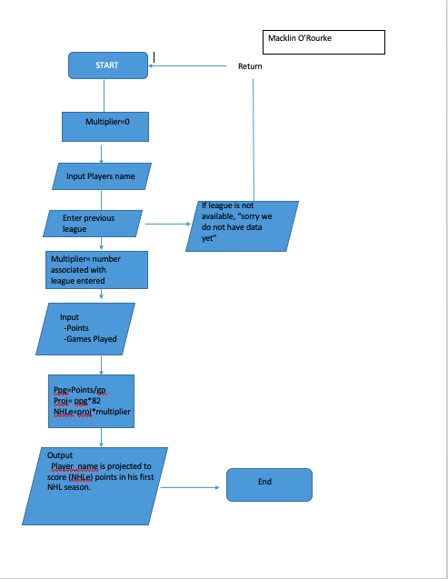

print ("Welcome to the NHL points estimator for first year players!")  
print("This program is designed to determine how many points a player will score in their rookie season.")  
  
  
###FORMULA TO FIND ESTIMATED POINTS  
##NHLE=((PTS/GP)*82)*LEAGUE MULTIPLIER  
#The Multiplier is essentially the strength of the previous league the player played in  
multiplier = 0  
#Ask for players name  
player_name = input("What is your player's name?")  
  
 #This function will print out the leagues we haved data for, and ask the user what league the player came from  
def stats():  
 print("Choose from the following leagues:")  
 print ("KHL")  
 print ("SHL")  
 print ("AHL")  
 print ("NCHC")  
 print ("CZECH")  
 print ("WCHA")  
 print ("FINLAND")  
 print ("SWISS")  
 print ("HEAST")  
 print ("CCHA")  
 print ("OHL")  
 print ("WHL")  
 print ("BIGTEN")  
 print ("ECAC")  
 print ("QMJHL")  
stats()  
league_name = input("What league did " + player_name + " play in?")  
#This function makes the input readable even if it is in lowercase  
league_name = league_name.upper()  
  
### This function will take the league the user inputed, and associate that league with a number, which I calculated  
## by looking at data from players coming to the NHL, and seeing how their production translates to the NHL level  
  
if league_name == "KHL":  
 multiplier = .727  
elif league_name == "SHL":  
 multiplier = .569  
elif league_name == "AHL":  
 multiplier = .470  
elif league_name == "NCHC":  
 multiplier = .468  
elif league_name == "CZECH":  
 multiplier = .457  
elif league_name == "WCHA":  
 multiplier = .440  
elif league_name == "FINLAND":  
 multiplier = .435  
elif league_name == "SWISS":  
 multiplier = .430  
elif league_name == "HEAST":  
 multiplier = .393  
elif league_name == "CCHA":  
 multiplier = .319  
elif league_name == "OHL":  
 multiplier = .306  
elif league_name == "WHL":  
 multiplier = .305  
elif league_name == "BIGTEN":  
 multiplier = .287  
elif league_name == "ECAC":  
 multiplier = .280  
elif league_name == "QMJHL":  
 multiplier = .262  
else:  
 print("Sorry, we don't have data for that league... yet")  
 print("Try again?")  
 exit()  
  
  
def info ():  
 print("The following questions are related to the previous years production.")  
info()  
  
###This function will ask for the players previous points and games played, which we use to find points per game  
## We multiply PPG by 82 (82 games in an NHL season), and then multiply that number times the league multiplier  
#We then compute the estimated points and print it  
  
#Ask For points in previous league  
pts = int(input("How many points did " + player_name + " score last season?"))  
  
#Ask for Games played in previous season  
gp = int(input("How many games did " + player_name + " score last season?"))  
  
###Processing  
  
ppg = pts/gp  
proj = ppg*82  
NHLe = proj*multiplier  
NHLe = str (NHLe)  
  
  
def main():  
 print(player_name + "is projected to score " + NHLe+ " points in the NHL")  
  
main()

**Conclusion**

Though no predictor will ever be 100% accurate, especially in sports where there are countless outside factors that influence production; this is a very solid baseline test to determine the amount of points a first-year player will score in the NHL. In order to make this code work better, I would input more data, and try to incorporate more advanced analytics such as coach’s play style, player usage, and more defensive statistics because not all NHL players value is based off points.

For more information or questions, please contact me at macklinorourke@gmail.com